Date access: 2020-03-09

<http://wjw.beijing.gov.cn/wjwh/ztzl/xxgzbd/gzbdyqtb/202001/t20200130_1621740.html>

From 23 o'clock on the 25th to 8 o'clock on the 26th, 3 new cases of pneumonia infected with new coronavirus were added in this city

Date: 2020-01-26 Source: Beijing Municipal Commission of Health

From 23 am to 8 pm on January 25, 3 new pneumonia cases of new coronavirus infection were reported in the city, all of which were the immediate family members of a previously diagnosed patient with a history of contact in Hubei in Beijing. All of them have been sent to designated medical institutions. Institutions for treatment.

From 23:00 on January 25 to 8:00 on January 26, a total of 54 confirmed cases were reported in the city, including 1 in Dongcheng District, 5 in Xicheng District, 8 in Chaoyang District, 13 in Haidian District, 3 in Fengtai District, and 1 in Shijingshan District. There were 4 cases in Tongzhou District, 1 case in Shunyi District, 2 cases in Daxing District, 5 cases in Changping District, and 11 cases came from overseas.

**从25日23时至26日8时，本市新增3例新型冠状病毒感染的肺炎病例**

日期：2020-01-26 来源：北京市卫生健康委‍

从1月25日23时至26日8时，本市新增3例新型冠状病毒感染的肺炎病例，均为北京此前一例有湖北接触史的确诊病人的直系亲属，目前均已送至定点医疗机构进行救治。

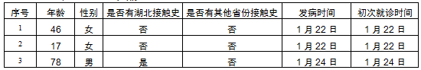

从1月25日23时至26日8时，本市累计确诊病例54例，其中东城区1例、西城区5例、朝阳区8例、海淀区13例、丰台区3例、石景山区1例、通州区4例、顺义区1例、大兴区2例、昌平区5例，外地来京人员11例。